

Faculty of Technology and Engineering
Chandubhai S. Patel Institute of Technology (CSPIT) Department of Computer Science & Engineering
Date:25/09/2026
Laboratory Manual

Academic Year | : | 2026-27 | Semester | : | 3rd
Course code | : | ITUE203 | Course name | : | WEB DEVELOPMENT FRAMEWORKS

Practical No: 7

Problem Statement: PHP Form, Post Method, Validation, Sanitization, File storage, Success Message, Error Message.

Objective: PHP Form – Create registration/contact form.
POST Method – Submit form using method="POST".
Validation – Check empty/invalid inputs.
Sanitization – Clean user input.
File Storage – Store data in CSV or JSON file.
Success Message – Show successful submission.
Error Message – Show validation errors.

GitHub Repository Link:
https://github.com/D26CS122/StudentHub
Screenshots:-
index.html: -
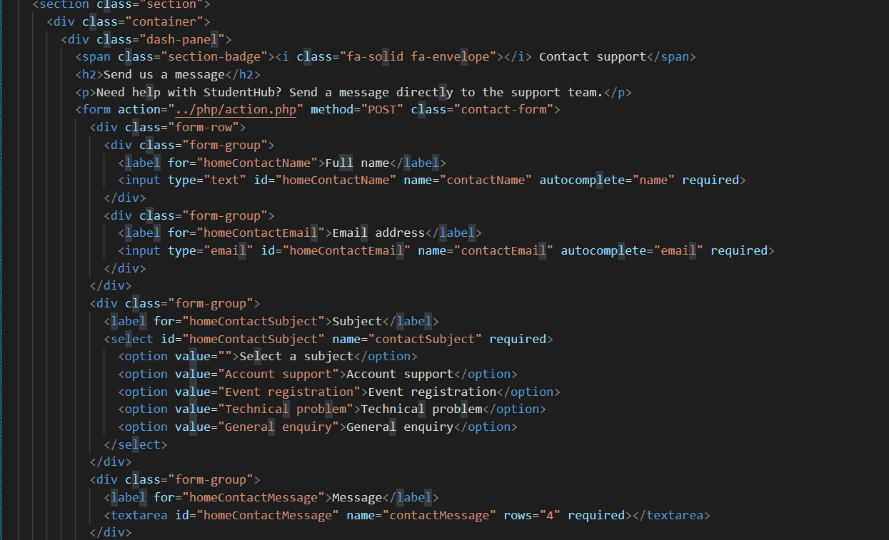
Action.php

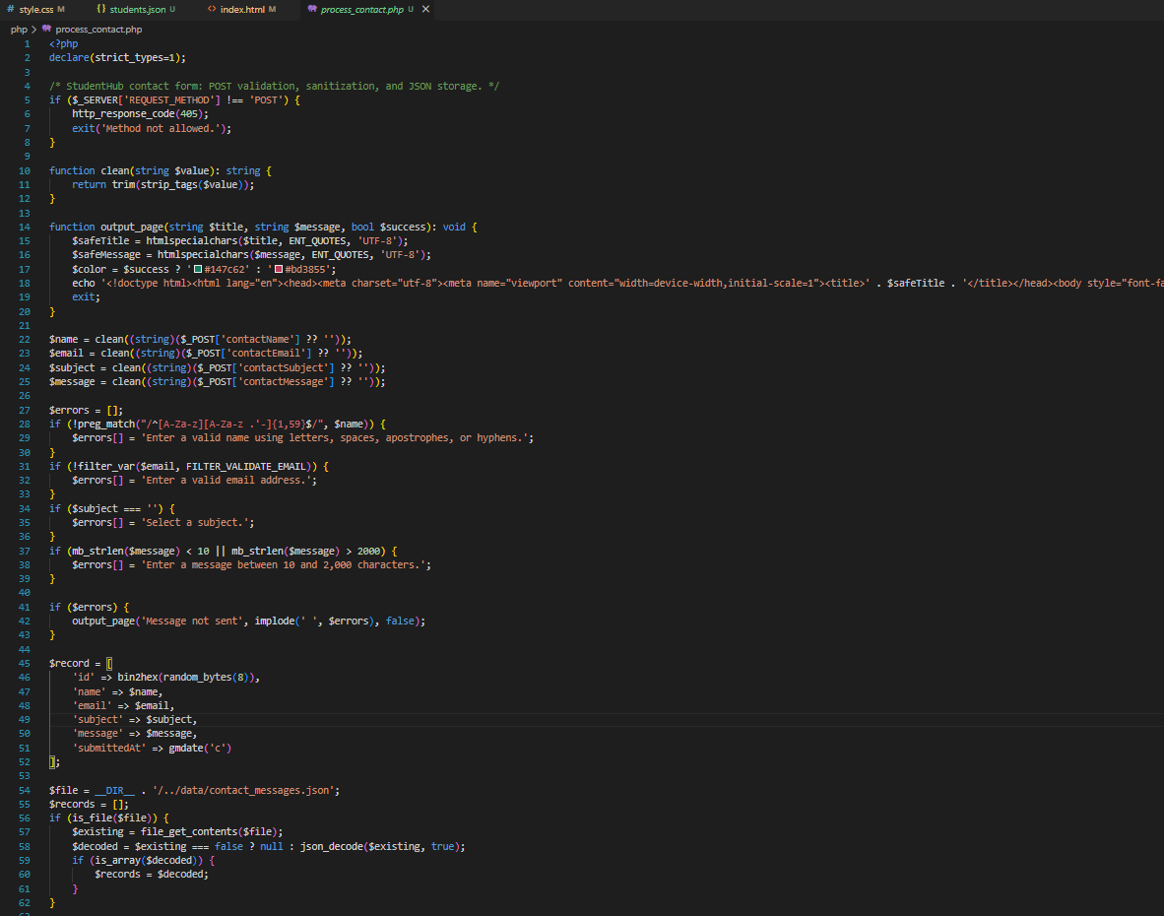

Error Messages:

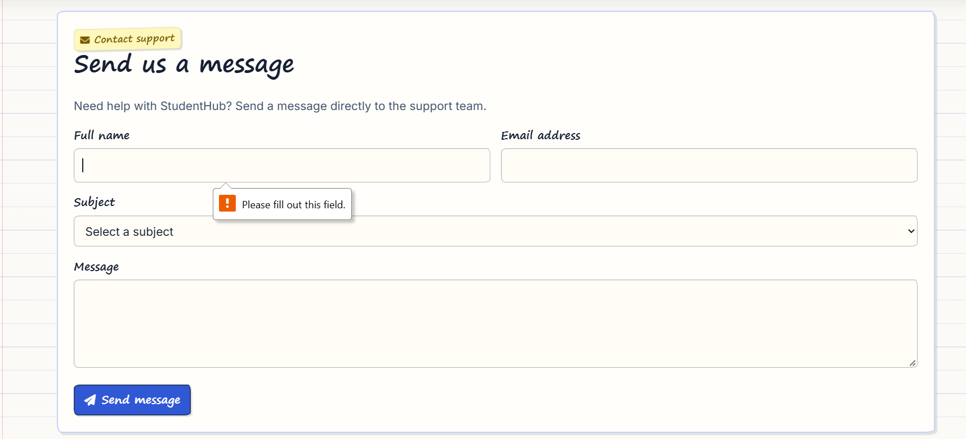

Form Submission:

Data entry in CSV file:

Data entry in JSON File:

